SINGLE-ZONE AUTOMATIC BURGLAR ALARM SYSTEM MINI PROJECT

The circuit was designed to provide an alarm system against any form of burglary based on the operation of CMOS 4011 where a high output would only result when any of the input is low.

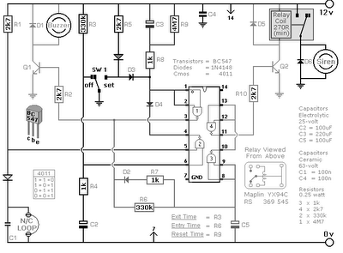

Terminology

Zone – refers to an alarm control panel’s input from a protective circuit which divides the alarm system into separate independent areas of protection based on function which may include medical, fire, intrusion, or critical condition monitoring

Burglar Alarm - one way of preventing break-in’s into one’s property, not only to protect the possessions but the occupants as well; can prevent the havoc and disruption caused by theft and break-in’BC547 – NPN small signal transistors designed for general purpose switching and amplification due to its low voltage, low current and three different gain selections CMOS 4011 – a quad 2-input NAND gate integrated circuit, generally characterized by small fluctuation in voltage supply, very high impedance, outputs that can sink and source, one output can drive up to 50 inputs, high speed gate propagation time, high frequency, and low power consumption

The zone designed in this circuit contains automatic entry and exit intervals with a bell having its cut off timer. It can also be applicable to other normally open and normally closed switches that contains input devices such as magnetic reed contacts, pressure mats, foil tapes, inertia sensors and passive infrared detectors. The buzzer will sound if the alarm is switched on wherein the loop is in open stage. On theother hand, as the switch turns off, the loop becomes a closed circuit again. The alarm will operate with any type of two-way switch.

The circuit is being powered by a 12 V supply, which is enough for as long as the buzzer, siren, and relay will match the supply input. The basicoperation of the alarm occurs with the interruption of electric current to a relay cause by deenergizing of the relay and making the relay contacts to operate the alarm indicator. The circuit is applicable to a single zone which can consist of a single point of contact. To start the circuit to function, the switch S1 should be set accordingly, but before doing this, all the LED should be properly lighting. Once the switch has been set, there will be an allotted thirty seconds to leave the premises which will trigger the buzzer to sound. It will only stop sounding when the door has been closed. In doing this procedure, it will ensure that the entry and exit operation has been restored effectively. Upon re-entering the premises, there will be 30 seconds time allotment to turn OFF the switch SW1. Failing to do this will trigger and energize the relay and eventually sound the siren. This can be deactivated at any time by turning OFF SW1. The alarm will reset, the relay will de-energize, and the siren will be cut-off once the loop has been restored after 15 minutes.

The delay timers in the circuit depend largely on the values and characteristics of the components used in the circuit, due to the manufacturing tolerances. The entry, exit and bell cut-off timer can be modified by altering the values of resistors R9, R6 and R3 depending on the prerequisite. By decreasing the values, the timer will also decrease; same thing with increasing the values will increase the timing.

Application:

A burglar alarm system helps detect unauthorized entry onto a company’s premises. The system sends a signal to a central monitoring center when activated. The monitoring centers provide 24/7 service and will alert the local police to dispatch authorities to the scene. It is a proven fact that the risk of burglary is significantly reduced after a burglar alarm is installed.